# **Erum Sikander Sunday 2 to 5 pm**

# **Hackathon - 3 Day 5**

**TESTING, ERROR HANDLING, AND BACKEND INTEGRATION REFINEMENT**

**API URL:** <http://localhost:3000/api/products>

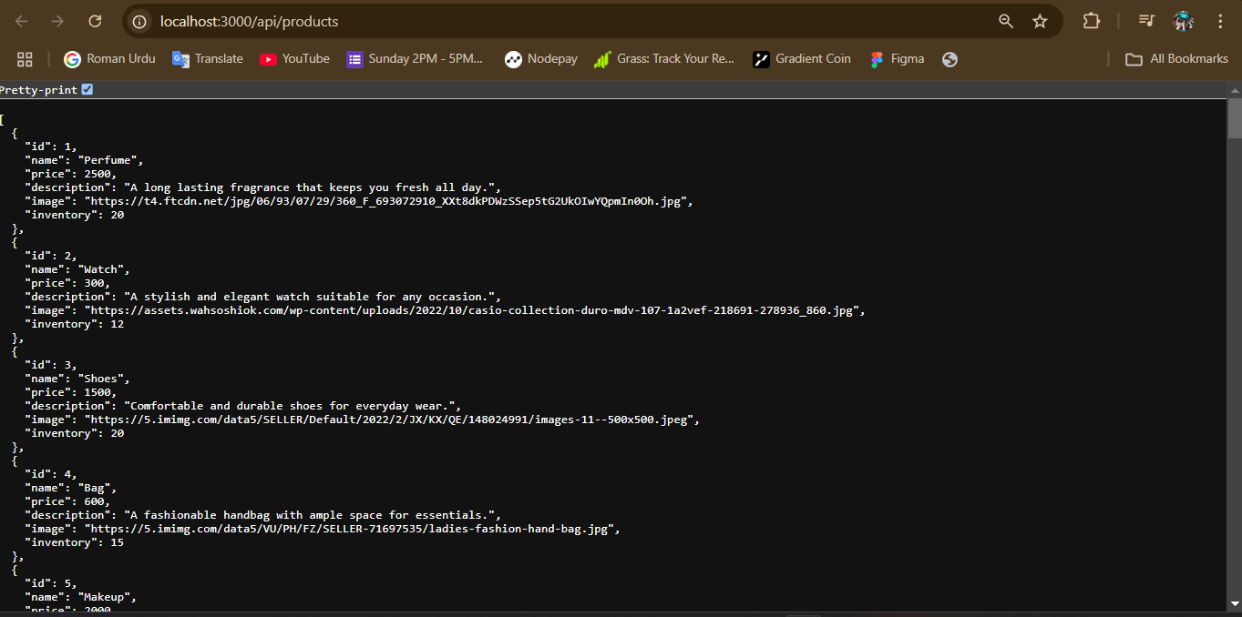

My website is working 100% mobile responsive, all functions are set, and the API data functionality is also working perfectly. Everything is functioning correctly according to Day 5 requirements because I worked a lot on it while facing many errors.

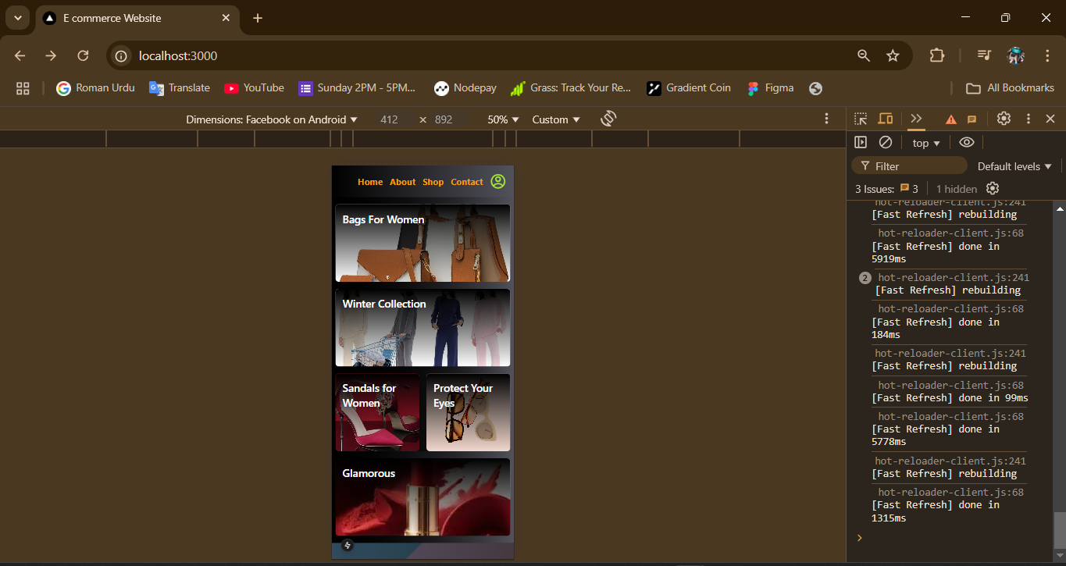

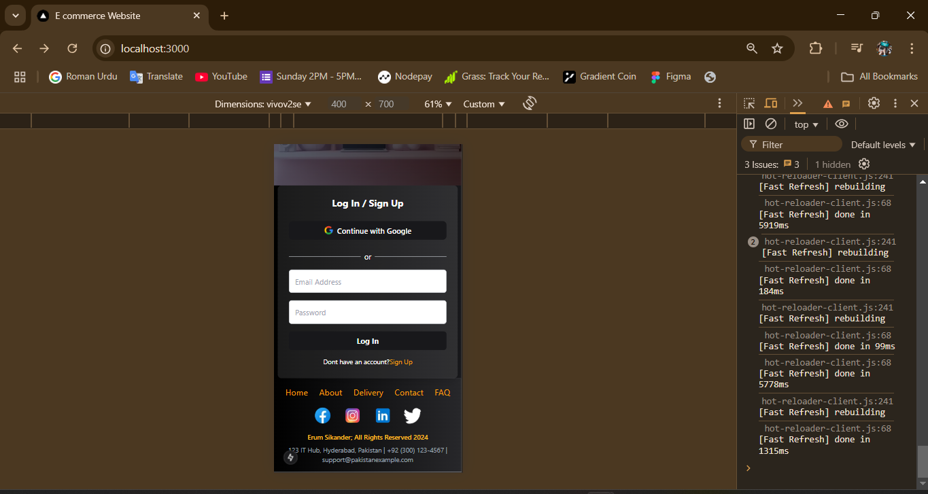

I tested my website using the Thunder Client extension in VS Code, and everything is working perfectly. All the GET and POST requests are returning a 200-status code, which means the APIs are functioning correctly. I verified the entire API functionality, and everything is operating smoothly in Thunder Client without any issues.

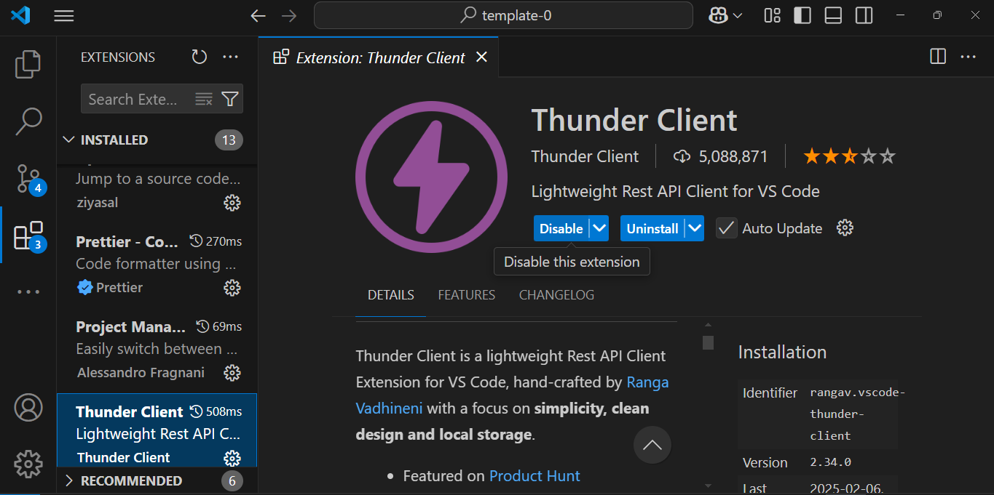

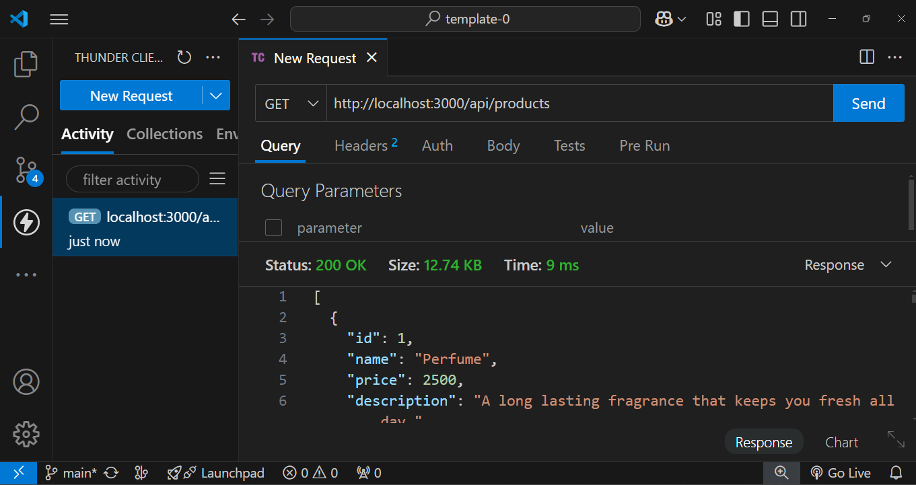

**This is Sanity’ vision data which that i created:**

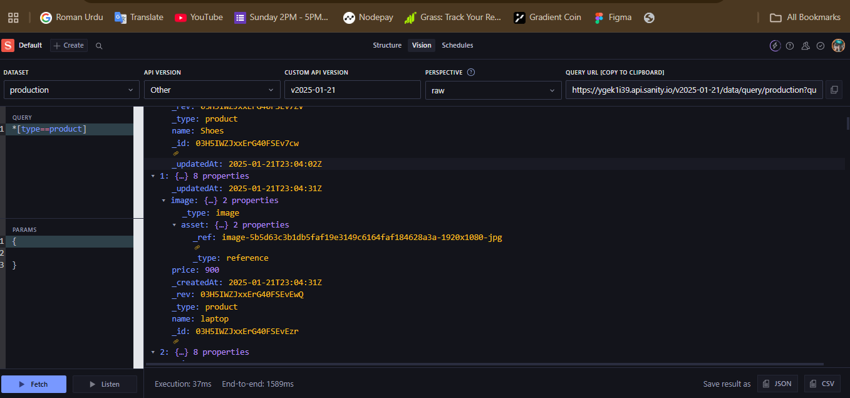

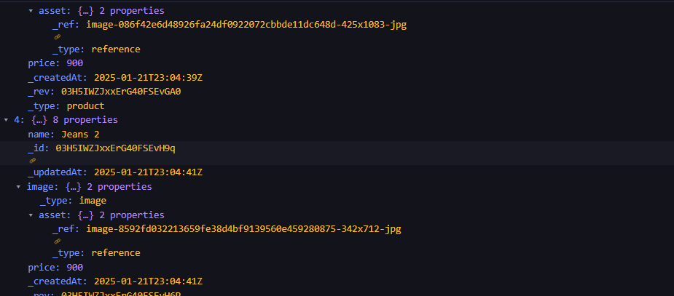

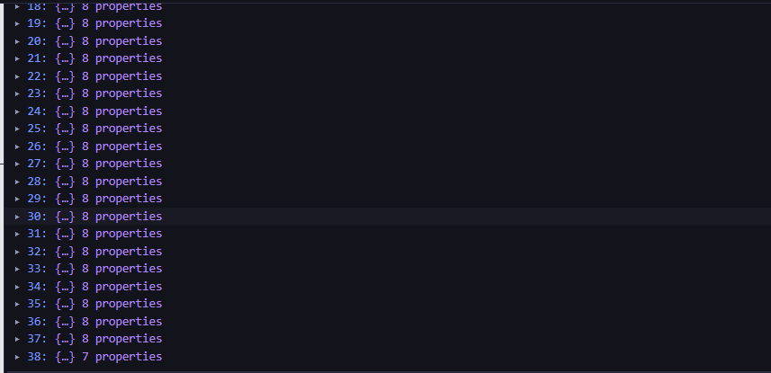

**Testing Report of lighthouse with Report percentages:**

**It’s my final Report of testing my website**

I have thoroughly checked my website using various methods. The overall performance percentages are mentioned below. Additionally, I have provided complete details of my website in the images attached, including all the data and reports generated through Lighthouse testing. You can review the performance, accessibility, best practices, and SEO scores in the reports for a comprehensive understanding of the website's current status.

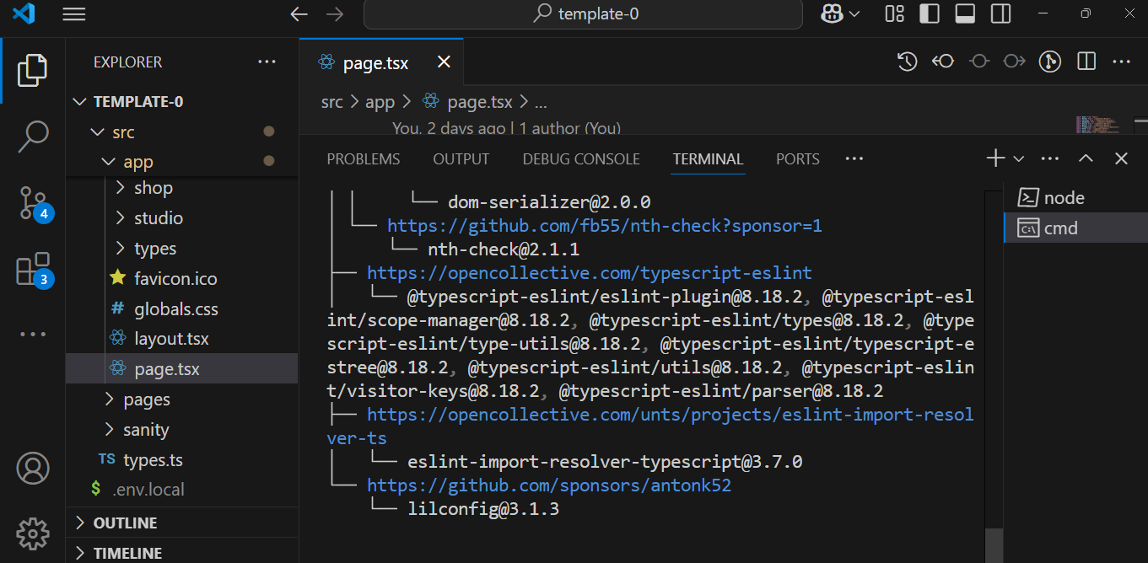

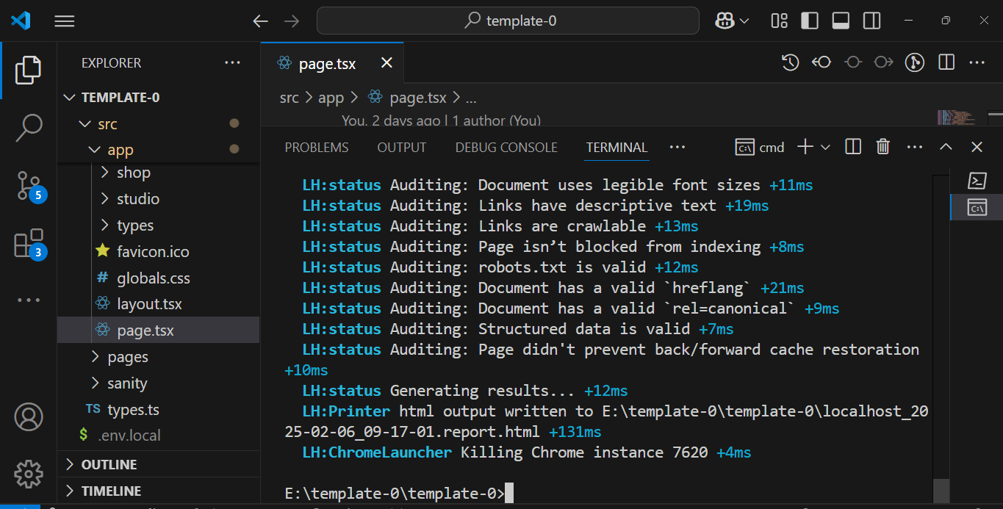

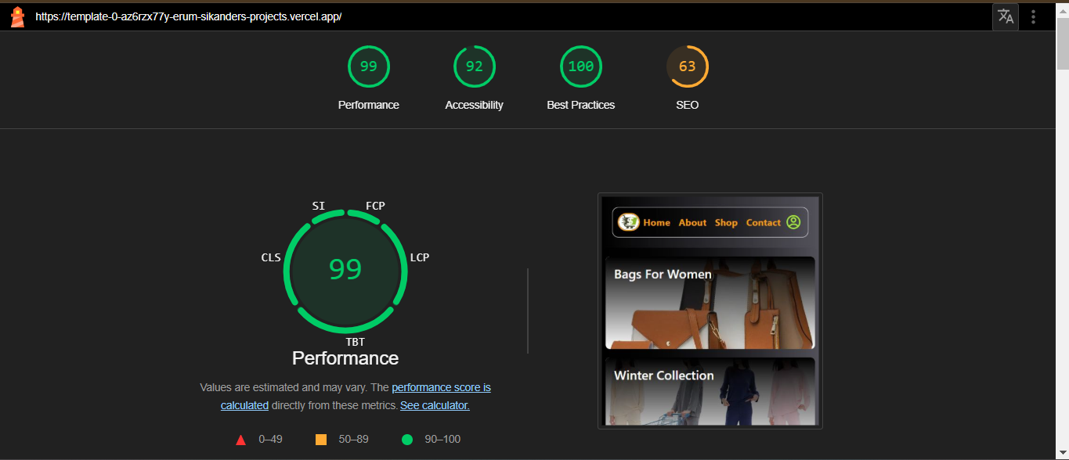

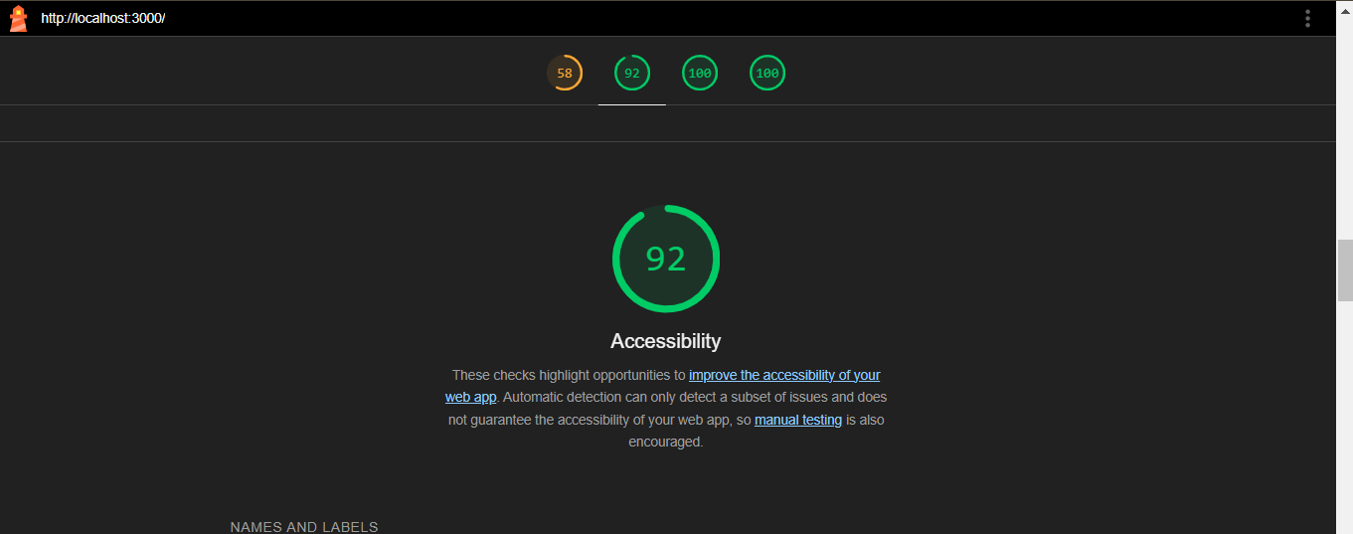

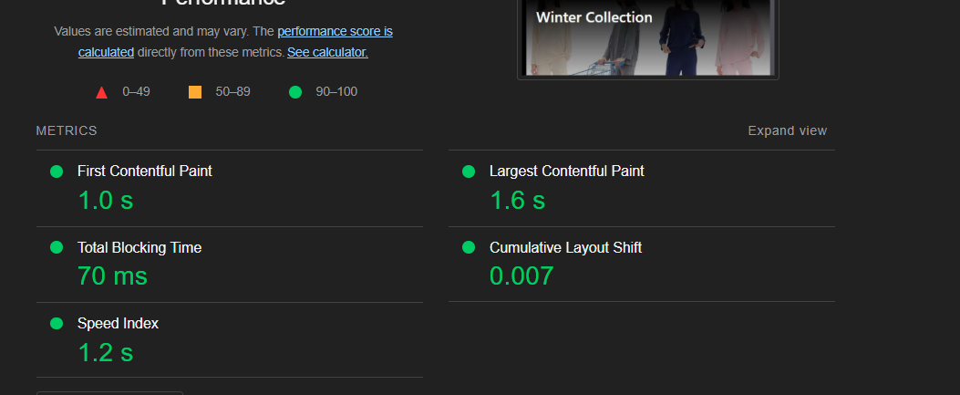

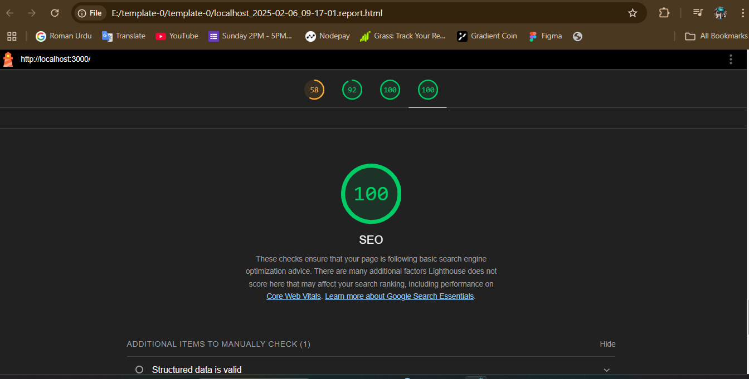

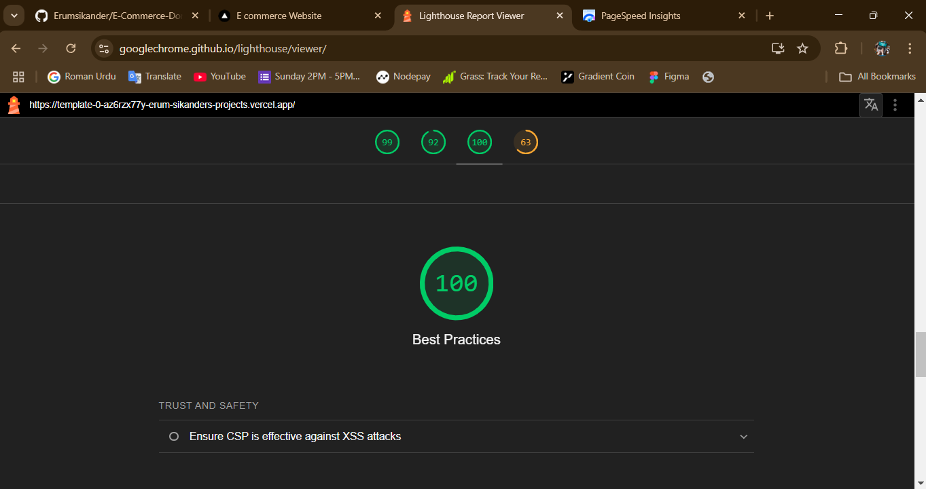

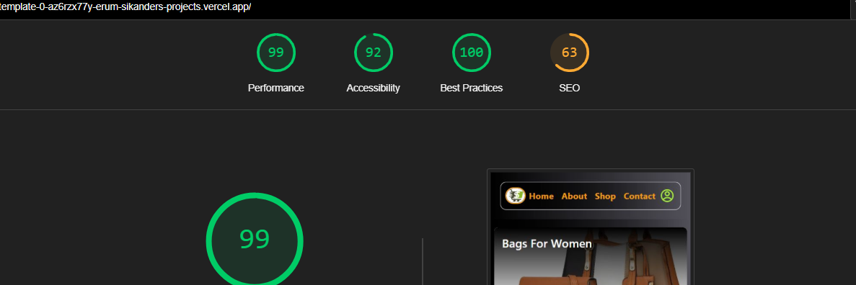

Building this **e-commerce website** was a big challenge for me. At first, I didn’t know where to start, and everything felt confusing. But once I began, I faced many errors and obstacles along the way. With hard work, sleepless nights, and continuous effort, I managed to fix everything and finally complete my website. I’m deeply grateful to **all my teachers**, especially **Sir Ameen Alam**, **Sir Ali Jawad**, **Miss Nida**, **Sir Sami**, and all the faculty members. Thank you for giving me the chance to learn and for guiding me through this journey. This project taught me so much, and because of your support, **I can now proudly call myself a Frontend Developer** my name is **Erum Sikander**, a senior student of the **Sunday 2 to 5 PM class**. Thank you for everything!

**Your obedient student,**

**Erum Sikander**

**Sunday 2 to 5 pm (Senior Student)**

**Thank You…!**